**Wall Mounted Animal**

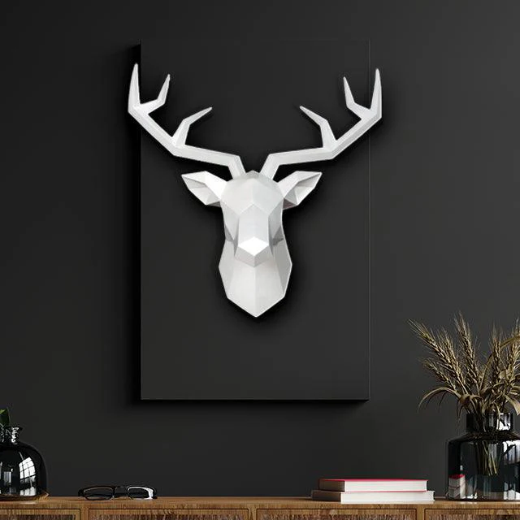A 3D white wall-mounted deer head is a modern and stylish piece of decor that adds a touch of elegance and sophistication to any interior. Crafted from materials like resin, metal, or wood, its sleek and minimalist design highlights clean lines and intricate detailing, making it a striking focal point. The white finish enhances its versatility, blending seamlessly with various color schemes and decor styles, from contemporary to rustic. Whether displayed in a living room, office, or entryway, this decorative piece exudes a sense of nature-inspired charm and artistic flair, transforming walls into captivating visual statements.